**Course:** ENSF 337 – Fall 2020

**Lab #:** Lab 9

**Instructor:** M. Moussavi

**Student Name:** Quentin Jennings

**Lab Section:** B03

**Submission Date:** 2020-12-01

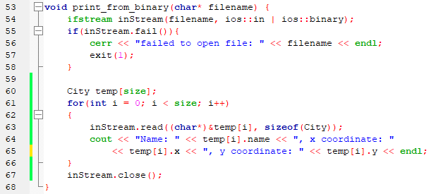Exercise B print_from_binary Function Definition:

Exercise B Output:

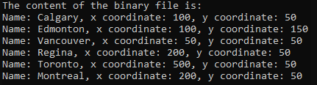

Exercise C transpose Function Definition:

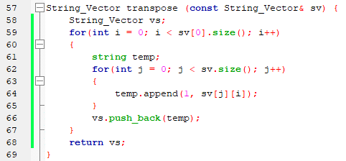

Exercise C Output:



Exercise D Point One Memory Diagram:

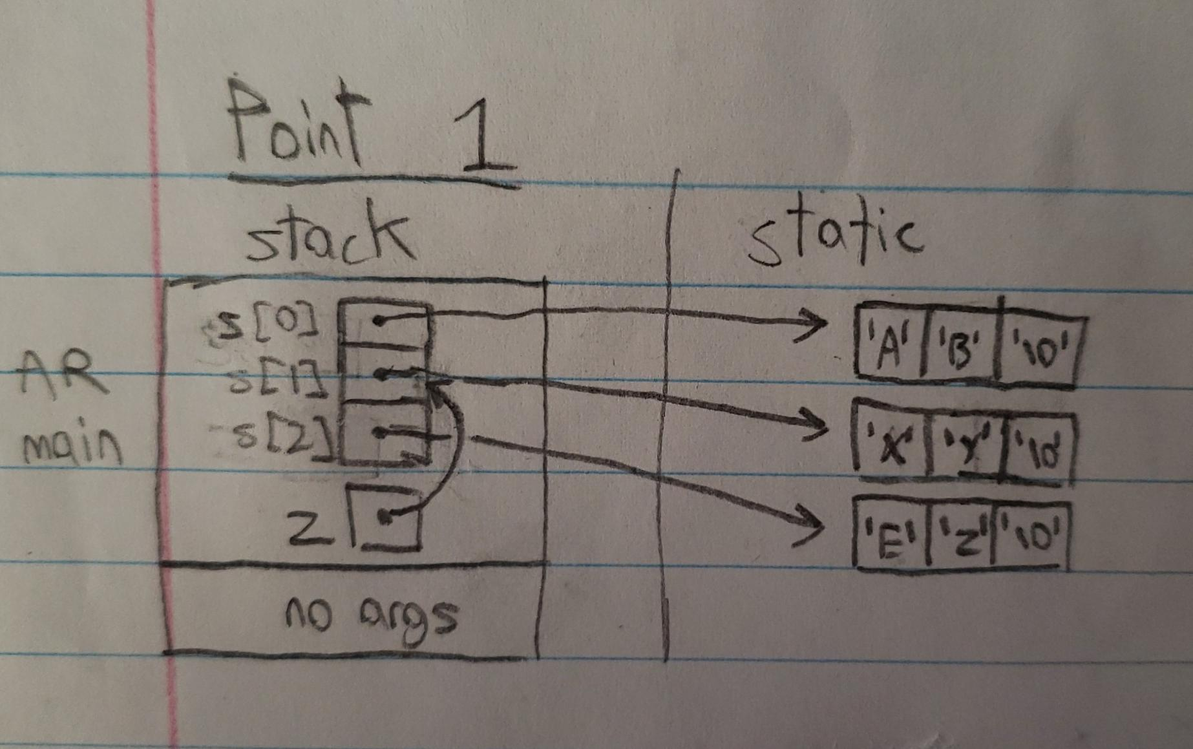

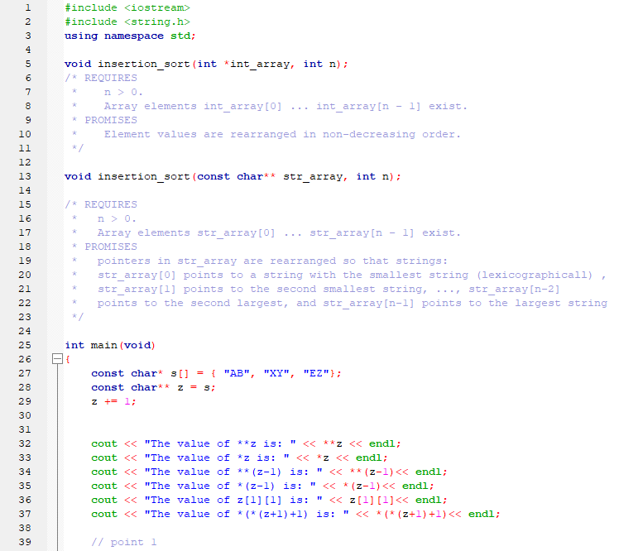Exercise D labyExD.cpp:

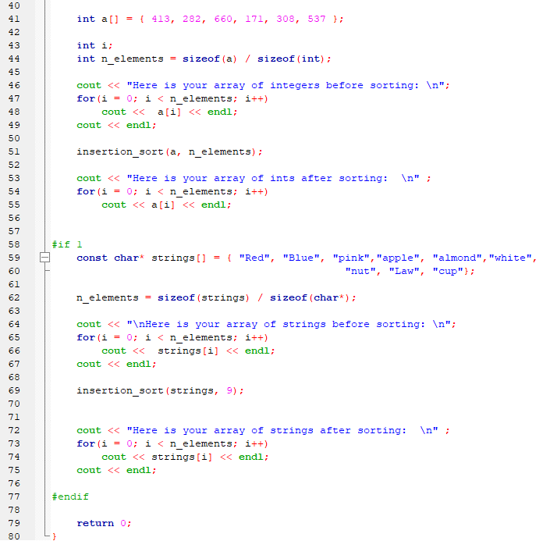

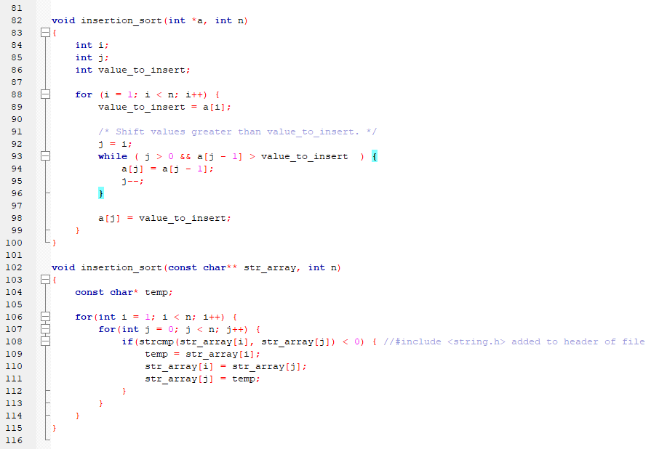

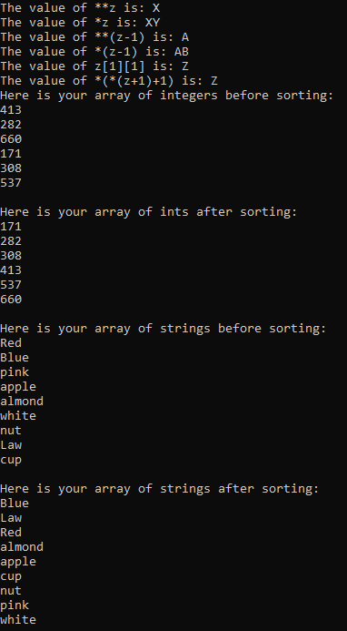Exercise D Output:

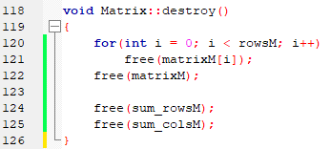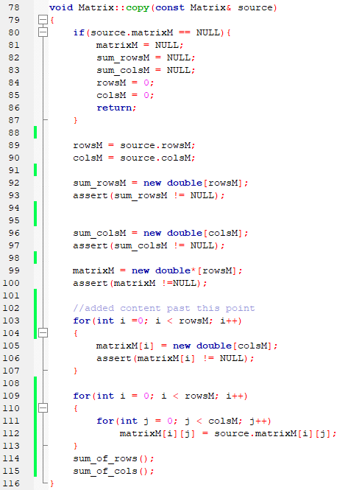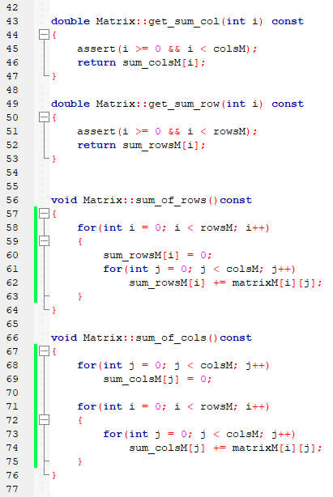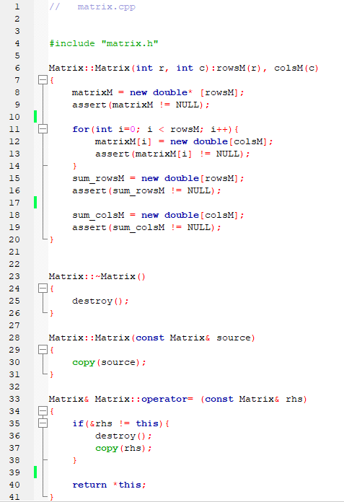Exercise E matrix.cpp:

Exercise E Output:

